***Faculty of Computing & Information Technology***

**CC-215-L: Database Systems Lab BSCS Fall 2022, Semester Spring 2024 LAB – 09**

**Lab Instructor**: Sanam Ahmad

**Teaching Assistant:** BCSF21M042 - Syed Farzand Ali

**Issue Date:** November 26, 2024

**TOPICS:** ERD DIAGRAM **Allowed Time:** 2 hours

**Instructions:** **Total Marks:** 30

1. Gossips are not allowed.
2. Teacher assistants are for your help, so be nice with them. Respect them as they are teaching you. Raise your hands if you have some problem and need help from TA. Avoid calling them by raising your voice and disturbing the environment of Lab.
3. TA may deduct your marks for any kind of ill-discipline or misconduct from your side.
4. Evaluation will be considered final and you cannot debate for the marks. So, focus on performing the tasks when the time is given to you.
5. Paste the query as well as result table screenshot as a result of each task



**Note:** Use **draw.io** or **Lucidchart** to create an **ERD (Entity-Relationship Diagram).**

**Task 01:** **__________ ____Catering Business Database Scenario _____** **(10 Marks)**

**Menu**:

* Each menu is uniquely identified by a Menu ID.
* Menus have attributes such as description and type (e.g., Breakfast, Lunch, Dinner).
* A menu contains multiple dishes but is served at one or more events.

**Dish**:

* Each dish is uniquely identified by a Dish ID.
* Dishes have attributes such as dish name, preparation time, and ingredients.
* A dish belongs to only one menu and includes specific ingredients listed in its preparation details.

**Event**:

* Each event is uniquely identified by an Event ID.
* Events have attributes such as event date, event location, and event time.
* An event has exactly one menu and one work schedule but can be associated with multiple staff roles.

**Work Schedule**:

* Work schedules are defined by attributes such as start time, end time, and position.
* Each event has one work schedule that may cover multiple events, depending on the staff availability and event requirements.

**Staff**:

* Each staff member is uniquely identified by an Emp ID.
* Staff have attributes such as name and salary.
* Staff members can take on different roles for each event as defined in the work schedule.
* A staff member may supervise multiple other staff members, but each staff member has only one supervisor.
* Staff members can work on one or more events, as outlined in their work schedules.



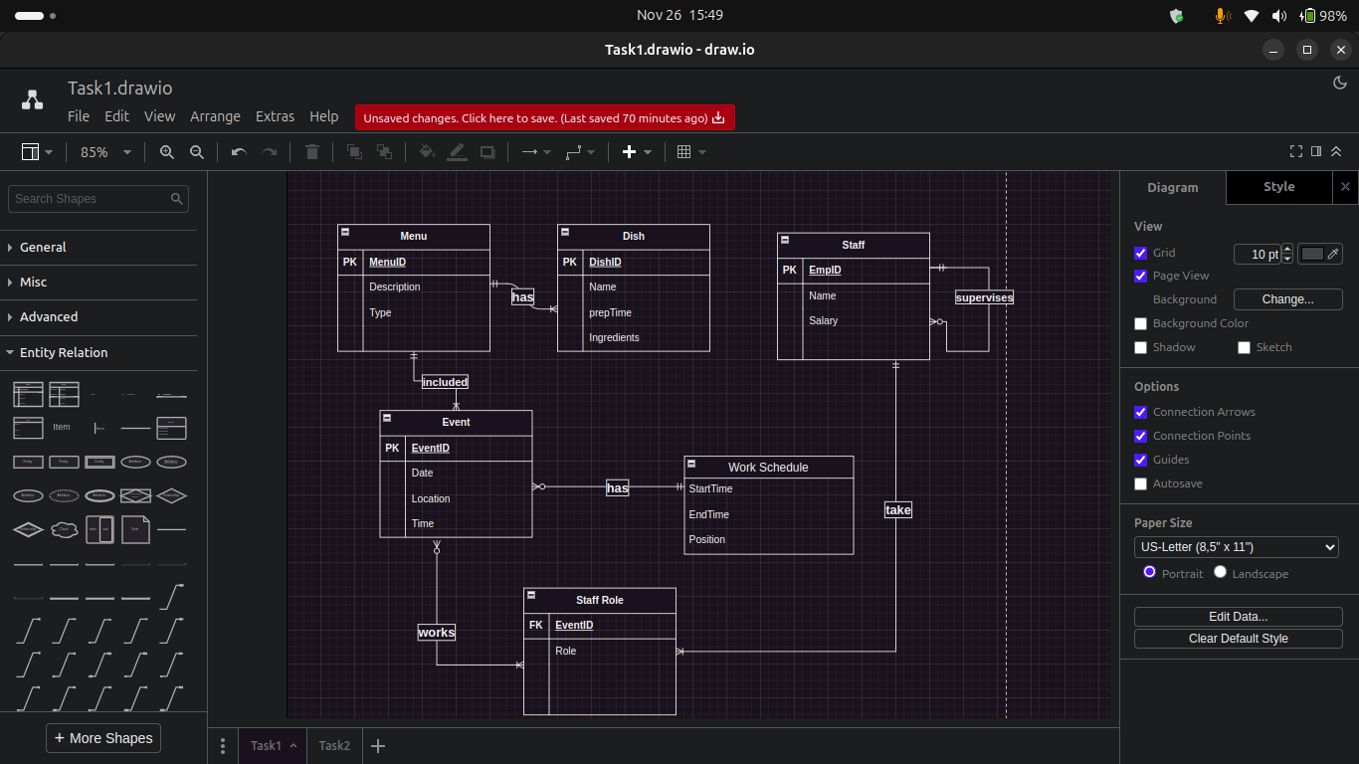

***A database query is like a treasure hunt. You need to know where to look and what to search for.***



***Faculty of Computing & Information Technology***

**CC-215-L: Database Systems Lab BSCS Fall 2022, Semester Spring 2024 LAB – 09**

**Lab Instructor**: Sanam Ahmad

**Teaching Assistant:** BCSF21M042 - Syed Farzand Ali

**Issue Date:** November 26, 2024

**Note**: **When constructing the ERD, it is crucial to accurately identify and label all primary keys (PK) and foreign keys (FK) for each entity in the database as per the specifications given. This ensures maintaining referential integrity and facilitating proper data linking across the database.**

**Task 02:** **_____________Tiny Hospital Database Scenario** **(20 Marks)**

A hospital keeps information on patients, doctors, patient appointments, bills, and hospital rooms. The system assigns each patient a patient ID. In addition, the patient's name, date of birth, and patient history are recorded. Some patients are resident patients who spend at least one night in the hospital, and others are outpatients who are treated and released.

Resident patients are assigned to a room. Each room is identified by a room number. The system can store the room type and room fee. Over time, each room will have many patients. Each resident patient will stay in only one room. Every room must have had a patient and every resident patient must have a room.

Outpatients can make many appointments with one or more doctors, and a doctor can accept appointments with many patients. However, each appointment is made with only one doctor and one patient. The appointments are of independent interest for the hospital, and it is required to maintain complete appointment history. For each appointment, a bill is charged from the patient.

**Note**: **When constructing the ERD, students should ensure to accurately identify and label all primary keys (PK) and foreign keys (FK) for each entity in the database as per the specifications given. This is crucial for maintaining referential integrity and facilitating proper data linking across the database.**



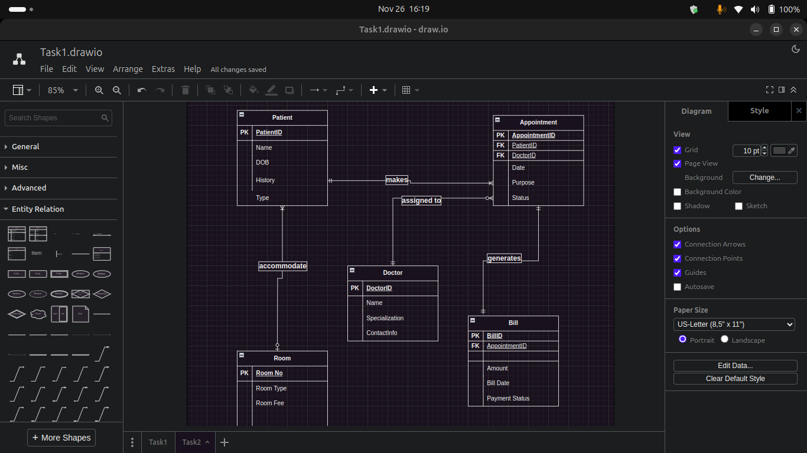

***A database query is like a treasure hunt. You need to know where to look and what to search for.***

